

Bank Management System

Software Design Document

Gyan Shankar Satapathy, Rajat Jain, Abhinav Sareen, Chinmoyee Saikia, Anmol Agarwal, Swati S

Group from PUN15-AJ012

**<Bank Management System>**

**Application Design**

**<Version No.1>**

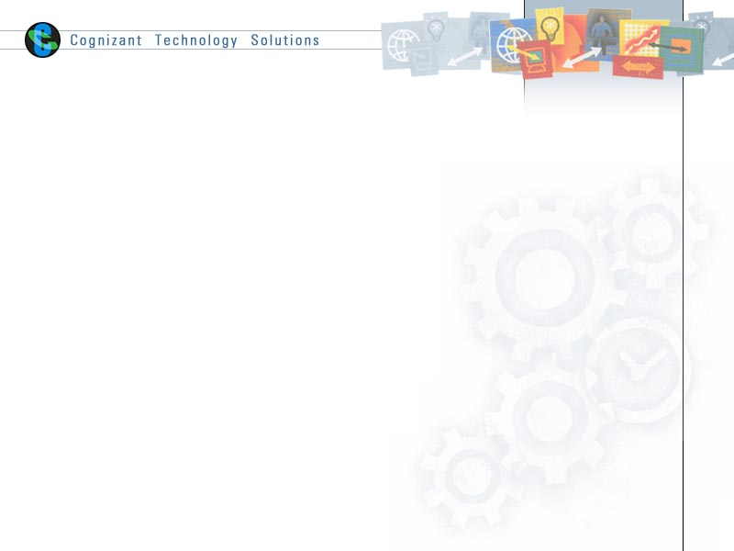

|  |  |  |  |
| --- | --- | --- | --- |
|  | **Prepared By** | **Reviewed by** | **Approved By** |
| **Name** |  |  |  |
| **Role** |  | Project Leader | Project Manager |
| **Signature** |  |  |  |
| **Date** |  |  |  |

Table of Contents

1.0 Introduction 3

1.1 Purpose of this document 3

1.2 Scope 3

1.3 Intended Audience 3

1.4 Definition & Acronyms 3

1.5 References 3

2.0 Conventions and Standards Followed 4

3.0 Assumptions, Dependencies and Risks 5

4.0 Use Case Realization 6

4.1 Flow of Events – Design 6

4.2 Derived Requirements 7

5.0 Package & Sub-system Design 8

5.1 Package Design 8

5.1.1 Packages 1…N 8

5.2 Sub-system Design 9

6.0 Generic Components Design 10

*7.0* Object Model 11

7.1 System Object Model 11

7.2 Object Descriptions 11

7.2.1 Object <Name> 11

8.0 Database Design 12

8.1 Data Model 12

8.1.1 Identification of Tables 12

8.1.2 Table Details 12

8.1.3 Referential Integrity Constraints 12

8.1.4 Computations/processing in Database 12

8.1.5 Access Control Details 12

8.2 Storage Characteristics 13

8.3 Database Performance Improvement Measures 13

9.0 References 13

10.0 Change Log 14

# Introduction

## Purpose of this document

To develop an intended application bank management system in order to automate the process of managing bank activities like opening an account, transaction, apply loan etc.

In the Software System following are the important modules

1. **Customer Registration**
2. **Apply loan**
3. **Update Profile**
4. **Transaction**
5. **Bank Statement Generation**

## Scope

The scope of the system is explained through its modules as follows

* **Customer Registration** – used by customers to register the details of self-information into the system. The system stores the details of the customer in the system along with the account details.
* **Apply Loan** - will be used by registered users to apply loan into the system. The system stores the loan details in the system along with the account details.
* **Transaction** - will be used by registered users to make Transactions on their accounts. The system stores the details of the Transaction types Deposit, Withdrawal, Loan EMI debit.
* **Update Profile** - will be used by registered users to update the details of account holder into the system. The system should update the details of the account holder in the system along with the account details.
* **Bank Statement Generation** - used by customers to view the bank statement.

## Intended Audience

* Mentor Manager
* Trainer
* Other Associates in the projects

## Definition & Acronyms

## References

# Conventions and Standards Followed

*<Please provide a list of all conventions and standards that will be followed in the design of the application>*

# Assumptions, Dependencies and Risks

*<This sub-section shall list all the assumptions and dependencies taken into account while preparing the Detailed Design document. Such assumptions are not outstanding issues, as they ought to be clarified with the customer. Rather they are valid assumptions on which the design is based>*

# Use Case Realization

*<The background or the reason that led to the initiation of the Business Context study to be mentioned here. >*

## Flow of Events – Design

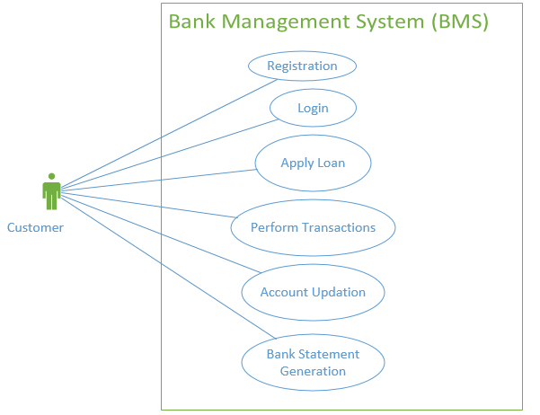

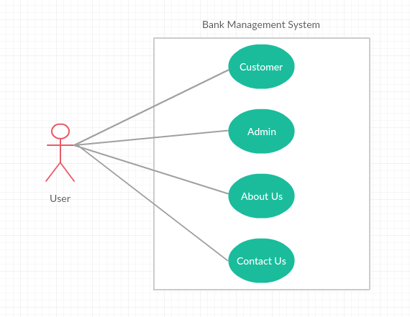

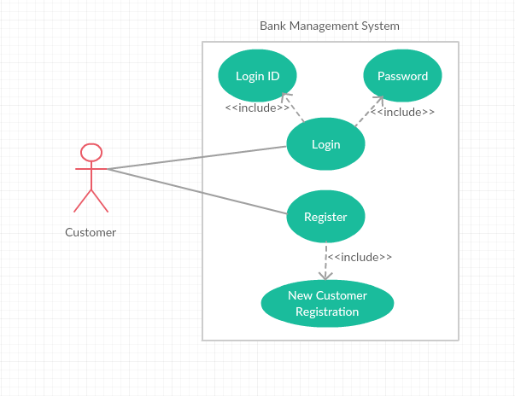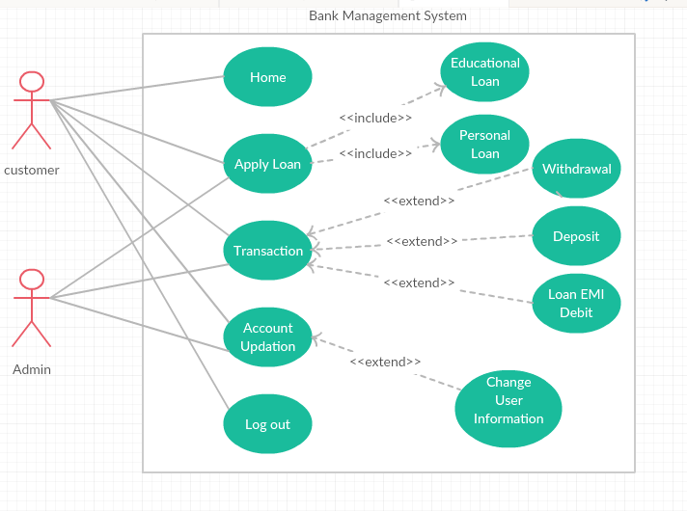

## Derived Requirements

### ER Diagram

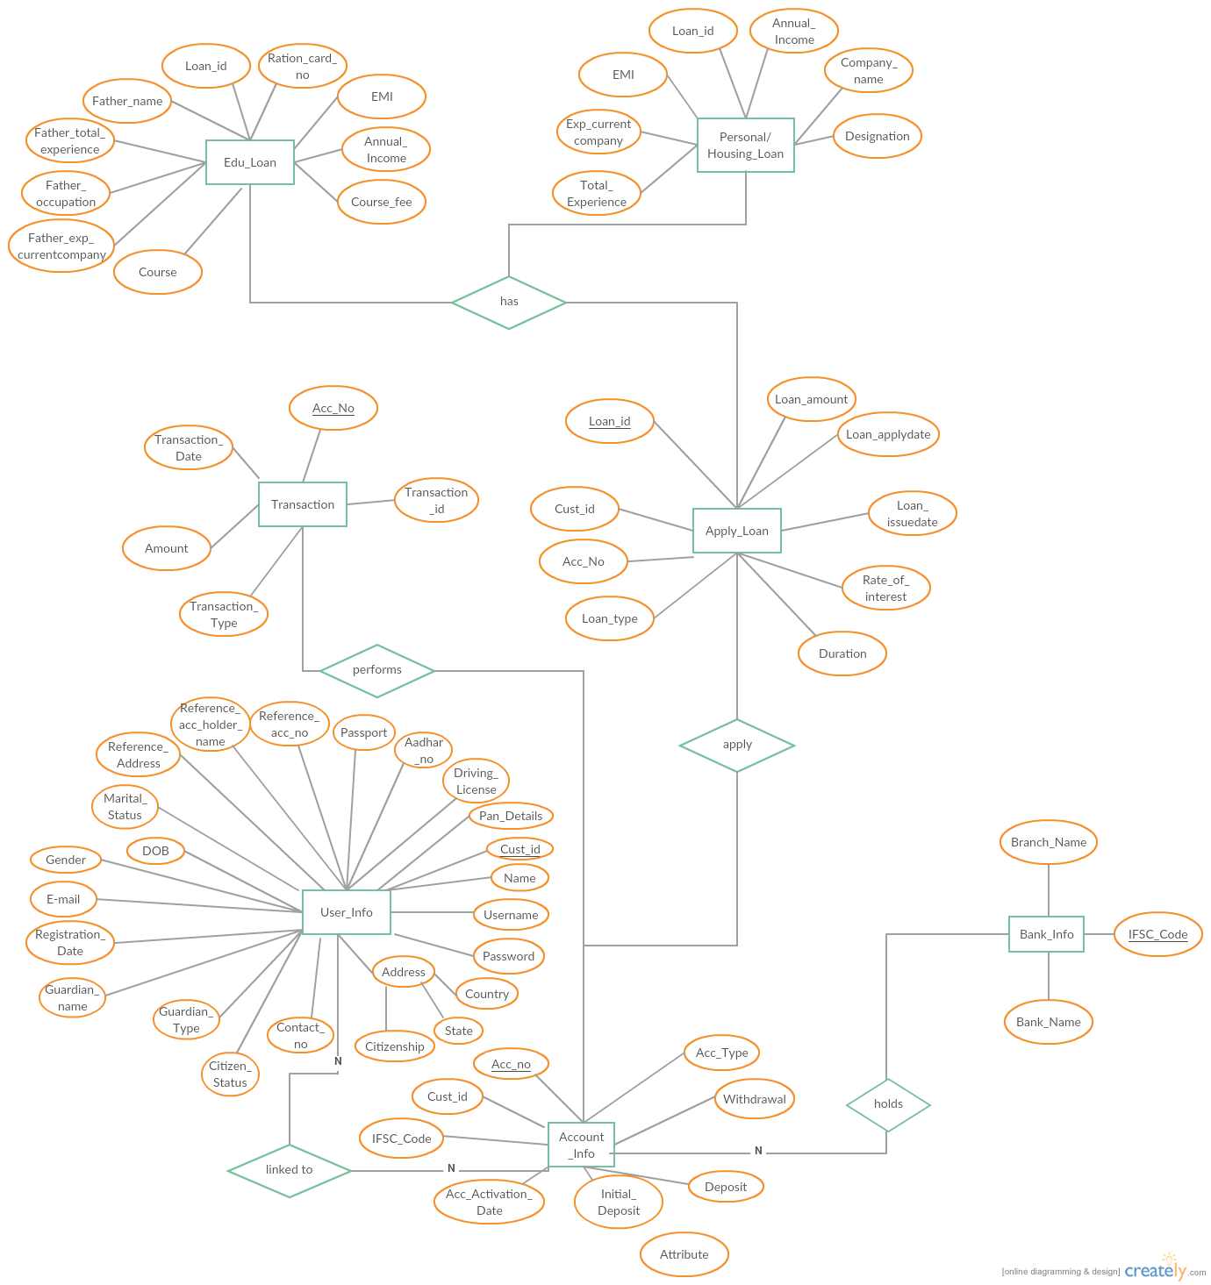

# Package & Sub-system Design

*<The purpose of this section is to explain the design over view of package or the sub system. The Design Model can be split into smaller units to make it easier to understand. By grouping Design Model elements into packages and subsystems, then showing how those groupings relate to one another, it is easier to understand the overall structure of the model>*

## Package Design

*<Packages are general-purpose hierarchical organizational units (units as in classes, relationships etc.). Such units are not contained in some other element. Elements such as attributes, operations, states, lifelines, and other messages are contained in other elements and do not appear as direct contents of packages.*

*A package may contain other packages. There is a root package that indirectly contains the entire model of a system. There are several ways to organize packages: - By view, BY functionality, or other relevant basis.*

* *If the packages are well chosen they can reflect the high-level architecture of the system.*
* *Identification of packages so that teams can work without interfering with each other.*
* *Delineating source code into logical partitions to enhance maintainability*
* *Implementing effective Configuration Management*
* *Access Control*

Constructing libraries etc.>

### Packages 1…N

*<Packages may be depicted here>*

|  |  |
| --- | --- |
| Attribute Name | Brief Description of Attribute |
| Name | The name of the package. |
| Brief Description | A brief description of the role and purpose, or the "theme" of the package. |
| Classes | The classes directly contained in the package. |
| Relationships | The relationships directly contained in the package. |
| Use-Case Realizations | The use-case realizations directly contained in the package. |
| Diagrams | The diagrams directly contained in the package. |
| Design Packages | The packages directly contained in the package. |
| Import Dependencies | The import dependencies from the package to other packages. |

## Sub-system Design

*<A subsystem is a physical unit of implementation with well-define interfaces that is intended to be used as replaceable part of the system. Each sub system embodies the implementation of certain classes. Well-defined subsystems do not depend directly on other sub systems but on interfaces that sub system support.*

*Note: If this already addressed as part of architecture, this may be skipped here and referenced here>*

|  |  |
| --- | --- |
| Property Name | Brief Description |
| Name | The name of the subsystem |
| Brief Description | The short description of the role and purpose, or the "theme" of the subsystem. |
| Interfaces | Associations to realized interfaces |
| Contents | Aggregation associations to contained model elements |
| Dependencies | Dependency associations to interfaces, packages, or subsystems on which the subsystem depends |
| Diagrams | Any diagrams local to the subsystem, such as class diagrams or statechart diagrams. |

# Generic Components Design

*<Generic design may include the following:*

* *Framework classes*
* *Audit Trial Classes*
* *Authority Checks*
* *Alarms/Error/Notification Requirements*
* *Operational Sequence Check*
* *Device Check*
* *Electronic Signatures*
* *Process Control Parameters*
* *Authorization*
* *Record Access*
* *Record retention & recovery requiremen>*

*A component is a physical unit of implementation with well-defined interfaces that is intended to be used as replaceable part of the system. Each component embodies the implementation of certain classes. Well-defined components do not depend directly on other components but on interfaces that components support>*

# Object Model

## System Object Model

*<Provide the object model for the whole system. If the model is too big, partition the diagram using some reasonable criteria. For example, you may provide the client-side and the server-side object models as separate diagrams>*

## Object Descriptions

*<In this section you would describe in detail each object, its attributes and its methods. You should logically group objects together. For example, you may use your architecture diagrams to group objects within a sub-system together. These may be directly referenced from Object Modeling tools if used in the project and maintained at the level given below >*

### Object <Name>

* **Purpose:**
* **Constraints**: None
* **Persistent**: No (created at system initialization from other available data)

#### Attribute Descriptions

1. **Attribute:**

**Type:**

**Description:**

**Constraints:**

1. **Another attribute…**

#### Method Descriptions

1. **Method:**

Return Type: *Boolean*

Parameters:

Return value: *success or failure*

Pre-condition:

Post-condition:

***2.* Attributes read/used:**

**3. Methods called:**

**4.Processing logic:**

# Database Design

## Data Model

*<Map persistent design classes into the data model>*

### Identification of Tables

*<While deriving tables from the object model, the different associations will need to be considered separately.*

*Example: A foreign –key reference for a 1:n relationship between customer and orders. In the case of aggregation association as in Order and Line items, ensuring a cascading delete will need to be factored. In many-to-many associations, an intersection entity will need to be considered (as in the case of many suppliers and many products.>*

### Table Details

*<Provide a tabular format, which captures the following details. While deriving tables from the object model, the different associations will need to be considered separately.*

*Example: A foreign –key reference for a 1:n relationship between customer and orders. In the case of aggregation association as in Order and Line items, ensuring a cascading delete will need to be factored. In many-to-many associations, an intersection entity will need to be considered (as in the case of many suppliers and many products.>*

### Referential Integrity Constraints

*<Specify all Primary Key, Foreign key, Triggers and other such constraints that enforce data integrity as well as referential integrity constraints>*

### Computations/processing in Database

*<Identify stored procedures that will access these tables and the operations that this will perform. Remember that improving database performance usually means reducing I/O; as a result, if performing a computation on the DBMS server will reduce the amount of data passed over the network, the computation should probably be performed on the server. However they must be used judiciously.*

*In collaboration with class design, ascertain how database can be used to improve performance. The operation method will need to be updated to indicate that one or more stored procedures can be/should be used to implement the operation. >*

### Access Control Details

*<Administrative details which are not specific to any program of the application, but connected to database/file system.*

* *Administration*
* *Security and access rights*
* *Record locking, etc>.*

## Storage Characteristics

*<Storage characteristics needs to be mentioned here and should include current as well as estimates for expansion in the future. This include some of the following:*

* *Disk page density*
* *Disk page location*
* *Disk space allocation etc*

## Database Performance Improvement Measures

* *Usage of Indexes to improve query performance (Keep in mind that indexes have a hidden cost: indexes cost time to update and occupy disk space. Be sure you get value from using them)*
* *Right choice of indexing strategy*
* *Query optimization*
* *Use of Prepared Statements and parameter binding*

*<INSERT YOUR DATA MODEL HERE>*

# References

# Change Log

*Please note that this table needs to be maintained even if a Configuration Management tool is used.*

|  |  |  |  |  |
| --- | --- | --- | --- | --- |
| Version Number | Changes made | | | |
| V1.0 | *<First version>* | | | |
| V1.1 | *<If the change details are not explicitly documented in the table below, reference should be provided here>* | | | |
| Page no | Changed by | Effective date | Changes effected |
|  |  |  |  |
|  |  |  |  |
|  |  |  |  |
|  |  |  |  |
| V1.2 | *<If the change details are not explicitly documented in the table below, reference should be provided here>* | | | |
| Page no | Changed by | Effective date | Changes effected |
|  |  |  |  |
|  |  |  |  |
|  |  |  |  |
|  |  |  |  |